Writing 11 – Acrostic Poem
Name: Caitlin Lo (21) Class: J.1 Honesty

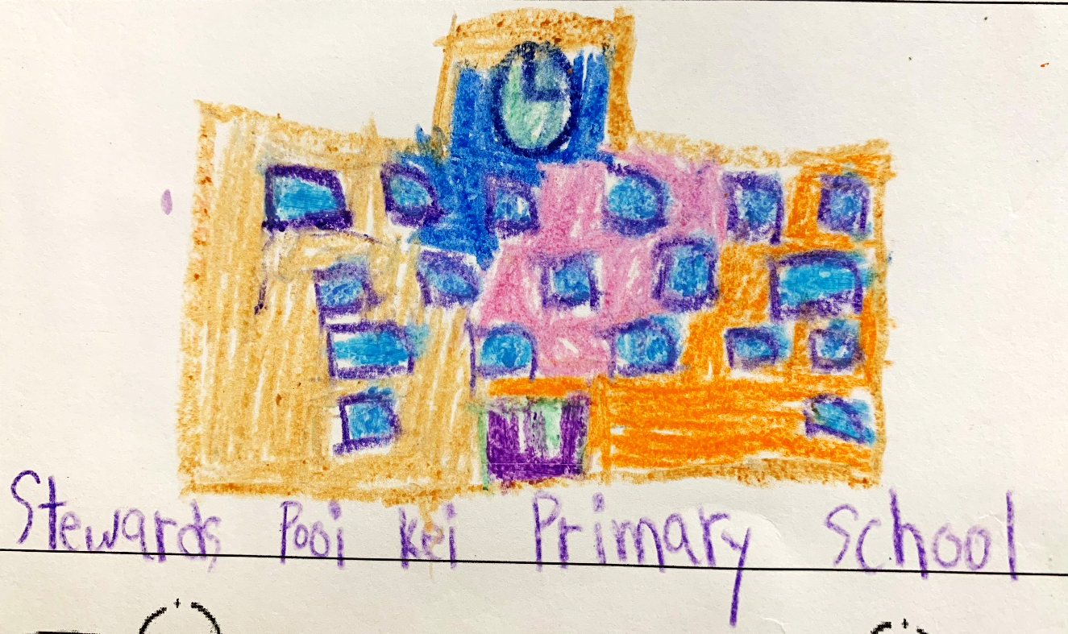

School

Stewards Pooi Kei Primary School.
Creates memories and dreams.
Happy places to have fun.
Offering knowledge, love and faith.
Oh my classmates,
Love our school together!

